Dateline 1902: First Attempt to Climb K2 PART I: The official portrait of the 1902 K2 expedition. Climbers, from left to right, are Wessely, Eckenstein, Guillarmond, Crowley, Pfannl, and Knowles.
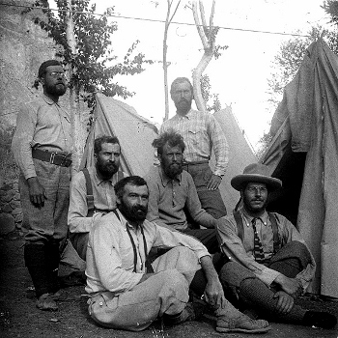
Things began to fall apart for the K2 expedition. The Austrian V. Wessely "was keeping himself in comfort by stealing the supplies of the expedition surreptitiously," including most of the emergency rations. He was summarily courtmartialed from the party and sent down the mountain. The rest of the men suffered from spending so much time at high altitude. Knowles had shed 33 pounds from his 186-pound frame; Eckenstein had pulmonary problems; Knowles and Doctor Guillarmod had recurrent influenza or similar symptoms; while Crowley soldiered on with malaria and high fevers. During one of the acrimonious arguments, Crowley pulled out a loaded revolver and pointed it at Guy Knowles, who kneed him in the groin in retaliation. Crowley interestingly never mentioned this incident in his expedition account in his book The Confessions of Aleister Crowley.

